**3 must-know advanced analytics for understanding your customers**

Top Use-cases for customer analytics and how to do them

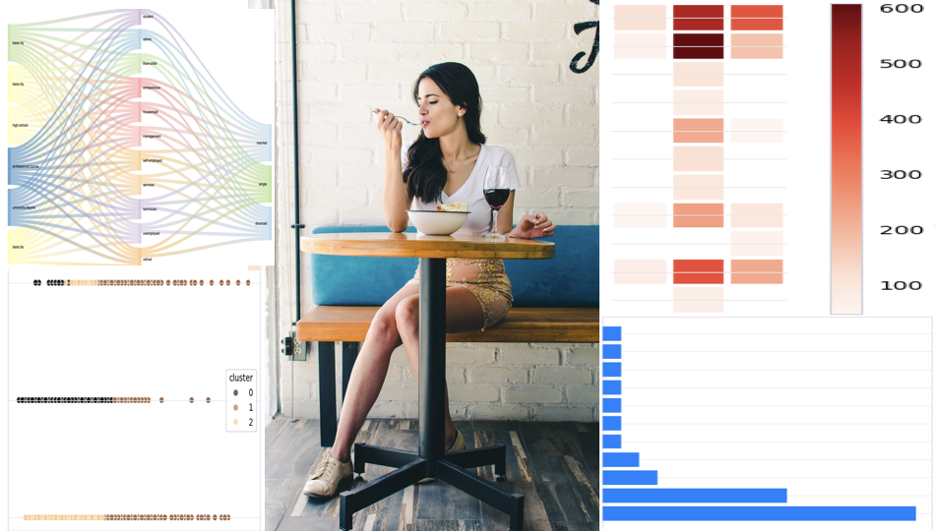

Photo by [Mike Mayer](https://unsplash.com/@mikeemayer?utm_source=unsplash&utm_medium=referral&utm_content=creditCopyText) on [Unsplash](https://unsplash.com/s/photos/customer-analytic?utm_source=unsplash&utm_medium=referral&utm_content=creditCopyText" \t "_blank) + additional analytic images

The top domain in which advanced analytics and data science is used is in understanding customers. And it is far more superior compared to any other domain — supply chain, IoT, finance etc.. And the reason is obvious — the success of your business depends upon how well you understand your customers. All other things will fall in place , once you have started to understand your customer in an effective way

Customer analytics is a very wide area. As well as every industry will analyse customers in a different way. However the top 3 customer analytics across all industries are the following

1. Customer Segmentation
2. Customer Journey Analysis
3. Marketing Attribution

Now let us see what are these analytics as well as what are the data science techniques are involved

**Customer Segmentation**

Customer segmentation, sometimes also called clustering, it allows you to make group of similar customers. So why is this useful? Say you want to make a marketing campaign and want to send email to your customers. So either you can send a common email to all your customers. Or you can send a “tailor-made” email to every customer.

Both these methods would be ineffective. In the first case, a common message to all your customers may not be suitable as each customer has his or her specific needs.

In the second case, you will be spending too much time in creating tailor made message for everyone.

So in order to solve this problem, customer segmentation is useful. It will group similar customer into segments. So now you can send an email message per segment. As customers in a segment are similar, you can tailor the message for each segment. Also as you save lot of time , as you are creating message for each segment and not for each customer

Here are some techniques which you can use for customer segmentation

**Heatmap — making segments based on pre-selected columns**

Let us assume that you have a dataset of customer with different attributes as shown here

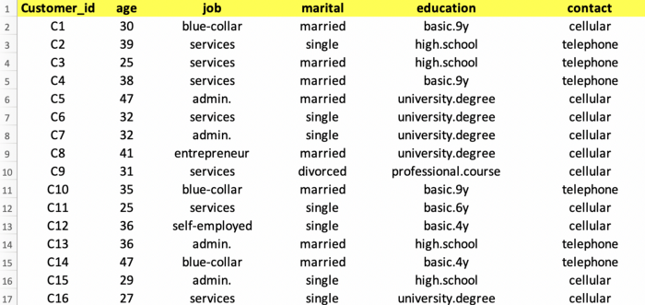

Image by Author

One way of making segments is based some columns which you already have in mind. For example, you can make segments based on Job and Marital status, and see which segment has most of the customers and which segment has least number of customers

A heatmap visualisation is a good way to find out segments visually, as shown below

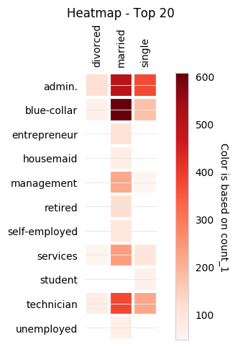

Image by Author

So as you can see that heatmap is a good way to segment the customers. Here you can see that most of the customers fall into segment of married and blue-collar. So you can tailor your marketing message to specific segments

**Making segments based on multiple columns**

n the section above, we made segments based on pre-determined columns such as job and martial status. However in many situations, you do not have specific columns in mind to make segments. So you can try to make segments on multiple columns. In this way , you let data tell you which segments are possible rather than any pre-determined segments

Clustering is a way to make segments using multiple columns. Clustering groups similar data records based on multiple columns into clusters or segments. Shown below is result of clustering shown as a scatter plot. Each customer record is represented as a point on the scatterplot. The segment or cluster is represented as a color. The analysis is to have three segment, so there are three colors.

Some of the columns which determine the clusters are **age, marital, education, job**.

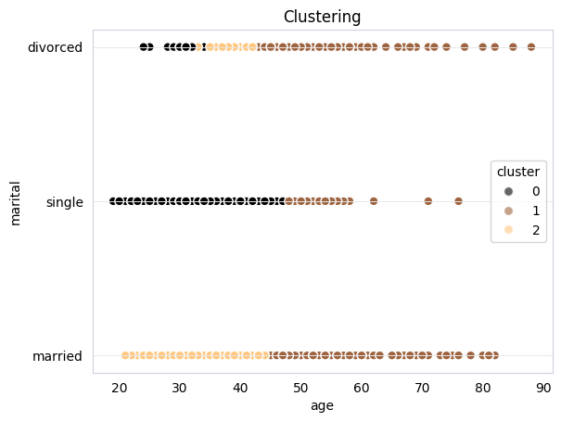

Image by Author

We can see that top two columns which determine the segments are age and marital status. So in this way, we did not have to predetermine any columns, but let data determine which could be the segments. This is being data-driven !!!

**Customer Journey Analysis**

Customer journey helps understand how customers interact with you in a chronological order. It helps you understand customer experience overtime. It encompasses all customer interactions across all channels, devices and touch-points throughout every stage of the customer lifecycle — from awareness to loyalty.

For example, a customer journey analytics would mean analysing how a customer is buying different products over a period of time. This would give insight into how a customer is progressing from a basic product to a premium product.

Here are some techniques to understand customer journey

**Path Analysis**

In order to illustrate this technique, let us look at a dataset which has customer transactions related to car rental booking. This data contains invoice details as well as information related to vehicle such as vehicle category and vehicle model

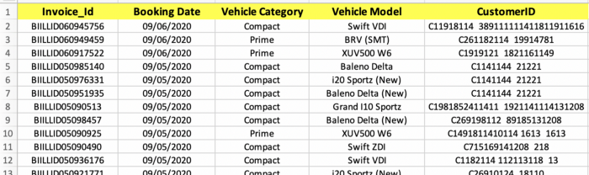

Image by Author

Using Path Analysis, we can determine the pattern of vehicle rented over time. As we can see that top paths for vehicle category are Compact — Prime.

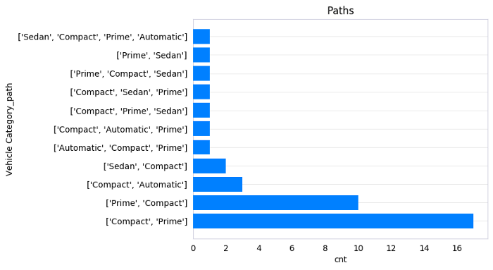

Image by Author

**Sankey Chart**

Another interesting technique to visualise path is using Sankey Charts. They represent the chronological events in a flow style visualisation. Shown below is all paths taken by customers. For example customers start with Sedan and then go towards Automatic cars

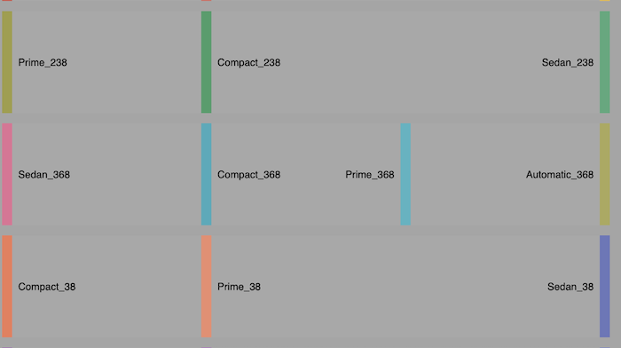

Image by Author

So as you can see that path analysis helps a lot in the customer journey. And this kind of analytics can be useful to in different ways — for example anticipating which path customer might take and then making product recommendations

**Marketing Attribution**

Marketing is key to let customer know about you and buy from you. And now-a-days there are various channels for marketing. The platforms on which businesses can market to their customers is increasing. Most customers are engaging with your content on multiple channels. So how do you decide effectiveness of the marketing channels? This is where attribution is useful as it helps you “attribute” the customer conversion to different channels.

Here are some techniques which will help you making marketing attribution.

**Channel Attribution analysis**

In order to illustrate this technique, let us take a sample dataset on website navigations by customers. The dataset contains information on cookie, time of interaction, interaction (whether impression or conversion), conversion (0=No, 1=Yes) and conversion value

The different channels are Paid Search, Video, Instagram, Facebook etc

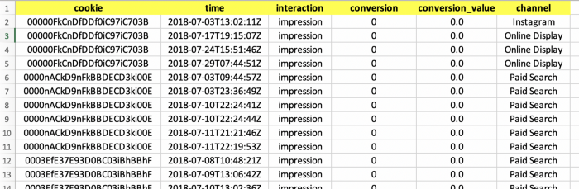

Image by Author

Let us zoom into some data related to some specific cookies

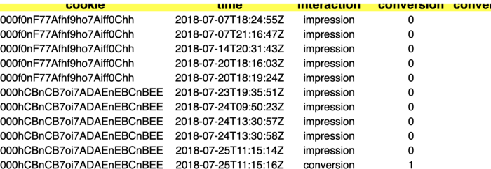

Image by Author

As you will see that the cookie 000f0nF77Afhf9ho7Aiff0Chh visited various channels, but there was no conversion. However the cookie 000hCBnCB7oi7ADAEnEBCnBEE visited various channels and it resulted into a conversion. The value of conversion was 6.5 and channel in which conversion took place was online video

Now even the conversion took place on the channel online video, the cookie had been on different channels such as Paid Search, Facebook, Instagram ,Online Video. So attribution will attribute the conversion value to these other channels proportionately

There are various ways of attribution. One of the most common way is to equally distribute conversion to all channels which led to conversion

The results are shown below. As you can see that Facebook channel has the highest attribution

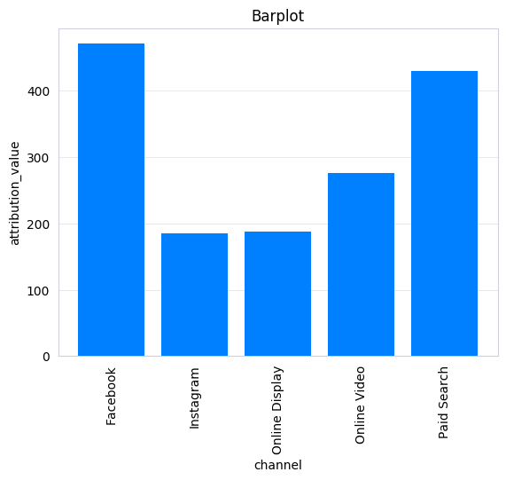

Image by Author

**Transition Matrix**

Transition Matrix gives you an overall picture on how the transition between different channels is happening. In addition you can also see which channels are leading to conversion

The transition matrix for the given data is shown here in form of a heatmap. As you can see that the maximum transition is from Instagram to Facebook. Also Facebook, OnlineVideo and PaidSearch are the channels which contribute most to conversion. This is in line with analysis done above. But in addition, you know that Instagram is the channel which has maximum transition to Facebook, which in turn has most conversion.

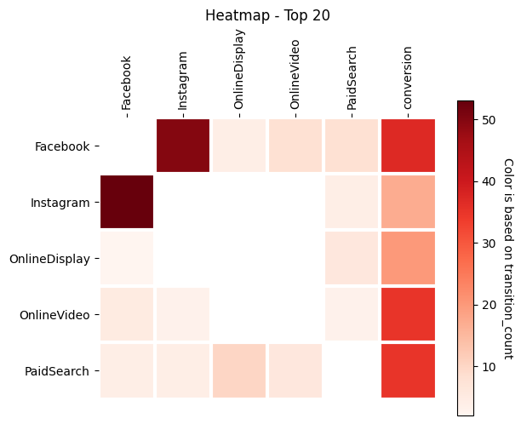

Image by Author

So that was a brief overview of top advanced analytics use-cases and techniques to better understand your customer. Once you master them, your business is destined to achieve new heights